
MATHEMATICS DEPARTMENT 2015
Year 11 Specialist - Test Number 1 – Basic Vectors Resource Free Section

Name: _______SOLUTIONS_____________________ Teacher: __________________
Marks: 30
Time Allowed: 25 minutes
Instructions: You ARE NOT permitted any notes or calculator.
_________________________________________________________________________
1 Which of the following best describes the direction of the position vector of P(4, −5)?
A 51°
B 219°
C −25°
D 309°
E 129°

[1 mark]
2 Calculate the resultant of the forces shown below.
A 21 N to the left
B 123 N
C 37 N to the right
D 21 N to the right
E 65 N to the left
[1 mark]
3 This diagram shows vectors m, n and a third vector.
Which of the following best describes the third vector?
A m + n
B −n + m
C n + m
D m − n
E n − m

[1 mark]
4 If a = −2i + 7j, which of the following vectors is opposite in direction to a?
A (−2, −7)
B
C 5i − 10j
D (6, −21)
E −7i + 2j

[1 mark]
5 This diagram shows vectors p and q.
Which of the following best represents the
resultant of p and q? (circle one)

[1 mark]

6 Which of the following is perpendicular to a = (0, −7)?
A i + j
B (−3, 1)
C −7i + j
D (−1, 1)
E −4i

[1 mark]

**End of Multiple Choice Questions**
7 Write the following vectors in polar form.
a A vector q with norm 6 in the positive direction of the y-axis $\left(6,90°\right)$

b A vector v of magnitude 8 in a direction 45° clockwise from the x-axis $(8,315°)$

[2 marks]
8 Convert the following vectors to component form.

a (8, 60°)
$(8\cos{60°},8\sin{60°})$
$=(8×\frac{1}{2}, 8×\frac{\sqrt{3}}{2})$
$=(4, 4\sqrt{3})$

b (5, 210°)
$(5\cos{210°},5\sin{210°})$
$=(-5\cos{30°},-5\sin{30°})$
$=(-5×\frac{\sqrt{3}}{2}, -5×\frac{1}{2})$
$=(-\frac{5\sqrt{3}}{2},-\frac{5}{2})$
[4 marks]

9 Convert the following vectors to polar form.
a (3,−3)
magnitude = $\sqrt{3^{2}+3^{2}}=\sqrt{2×9}=3\sqrt{2}$
reference angle = $45°$ but in Q4 so $315°$
$(3\sqrt{2}, 315°$)

b ($-\sqrt{3}$, 1)

magnitude = $\sqrt{3+1}=\sqrt{4}=2$
reference angle = $\tan^{-1}\left(\frac{1}{\sqrt{3}}\right)=30$ but in Q2 so $150°$
$(2, 150°$)

[4 marks]
10 Find the norm of each of the following vectors.

a (−2, 7)
$norm=\sqrt{4+49}=\sqrt{53}$

b

Pythagorean Triple: 10, 24, 26
$∴norm is$26

[2 marks]

11 Given d = (8, −2) and e = (−4, −2), find:

4(2d − 3e)
$=4\left(2\left(\begin{matrix}8 \\ -2\end{matrix}\right)-3\left(\begin{matrix}-4 \\ -2\end{matrix}\right)\right)$
$=4\left(\left(\begin{matrix}16 \\ -4\end{matrix}\right)-\left(\begin{matrix}-12 \\ -6\end{matrix}\right)\right)$
$=4\left(\begin{matrix}28 \\ 2\end{matrix}\right)$
$=\left(\begin{matrix}112 \\ 8\end{matrix}\right)$

[2 marks]
12 Write the following vector as a linear combinations i and j.
a m = (2,−5)

$2i-5j$
[1 mark]
13 Find the value of α and β given that m and n are non-parallel vectors and the following is true:
(α-β+1)m=(β-3)n

α-β+1=0 and β-3=0

α-3+1=0 β=3

α=2

[3 marks]
14 Given $a$ = (5, 20$°$) state $\hat{a}$.
$(1,20°)$
[1 mark]

15 OABC is a trapezium with OC parallel to, and twice as long as, AB. D is the mid-point of BC.
If $\vec{OA}=\tilde{a}$ and $\vec{AB}=\tilde{b}$, express each of the following in terms of $\tilde{a}$ and/or $\tilde{b}.$
$\vec{BC}=-\tilde{b}-\tilde{a}+2\tilde{b}=\tilde{b}-\tilde{a}$
$\vec{OD}=\vec{OA}+\vec{AB}+\vec{BD}$
$=\tilde{a}+\tilde{b}+\frac{1}{2}(\tilde{b}-\tilde{a})$
$=\tilde{a}+\tilde{b}+\frac{1}{2}\tilde{b}-\frac{1}{2}\tilde{a}$
$∴\vec{OD}=\frac{\tilde{a}}{2}+\frac{3\tilde{b}}{2}$

[5 marks]

MATHEMATICS DEPARTMENT 2015
Year 11 Specialist - Test Number 1 – Basic Vectors Resource Rich Section



Name: ______SOLUTIONS____________________ Teacher: __________________
Marks: 20
Time Allowed: 20 minutes
Instructions: You ARE allowed 1 page of notes (both sides) and a CAS calculator.
You must show your working to receive full marks whenever a question is worth more than 2 marks.
_________________________________________________________________________
16 Given f = (20, 46°), g = (18, 144°) find f + g by first changing to component form. Give your answer in polar form to the nearest whole number.
$\left(\begin{matrix}13.89… \\ 14.386…\end{matrix}\right)+\left(\begin{matrix}-14.56… \\ 10.580…\end{matrix}\right)=\left(\begin{matrix}-0.669… \\ 24.9669….\end{matrix}\right)≈\left(\begin{matrix}25 \\ 92°\end{matrix}\right)$

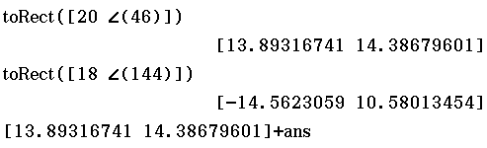
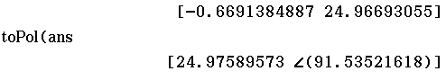

[3 marks]
17 Find the displacement vector for the following movement.
A(3, 4) to B(5, −3)
(5,-3) – (3,4) = (2,-7)

[1 mark]
18 Use a parallelogram of vectors to demonstrate that addition of geometric vectors is commutative.
Vector addition is commutative because the diagram shows a + b = b + a.

[2 marks]
19 State a vector parallel to $\left(\begin{matrix}3 \\ 2\end{matrix}\right)$ with a magnitude the same as the vector $\left(\begin{matrix}3 \\ -4\end{matrix}\right)$. Leave your answer in exact form.

$\left|\left(\begin{matrix}3 \\ 2\end{matrix}\right)\right|=\sqrt{13}$ $∴Unit vector is \left(\frac{3}{\sqrt{13}},\frac{2}{\sqrt{13}}\right)=\left(\frac{3\sqrt{13}}{13},\frac{2\sqrt{13}}{13}\right)$

$\left|\left(\begin{matrix}3 \\ -4\end{matrix}\right)\right|=5$ $∴Vector is \left(\frac{15\sqrt{13}}{13},\frac{10\sqrt{13}}{13}\right)$

[3 marks]
20 Given x = (27, 216°) and y = (22, 342°), find x + y without changing to component form. (to 1 d.p.)
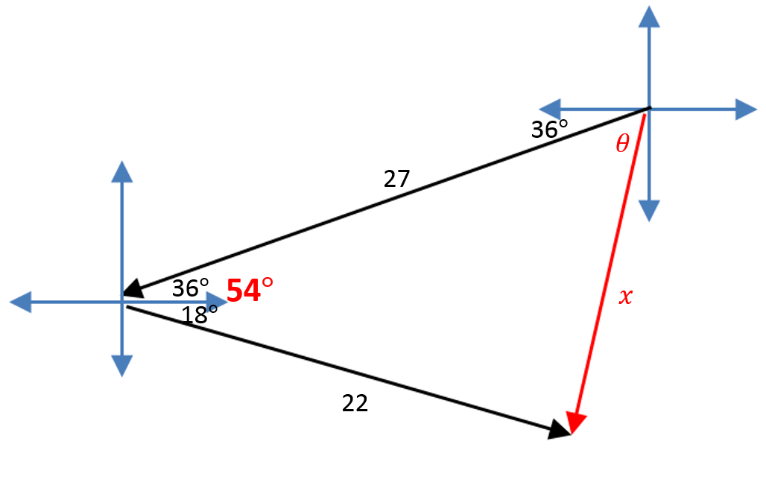

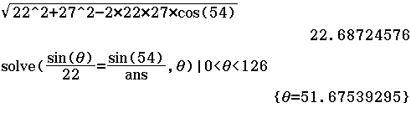
$∴Polar angle is 216+51.67…=267.67…°$
$x+y=(22.7, 267.7°$)

[5 marks]
21 A car travelling at 12 m/s at a bearing of 293° changes to 15 m/s at a bearing of 015°. What is the change
in velocity? (to 1.d.p.)
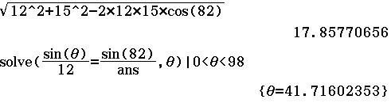
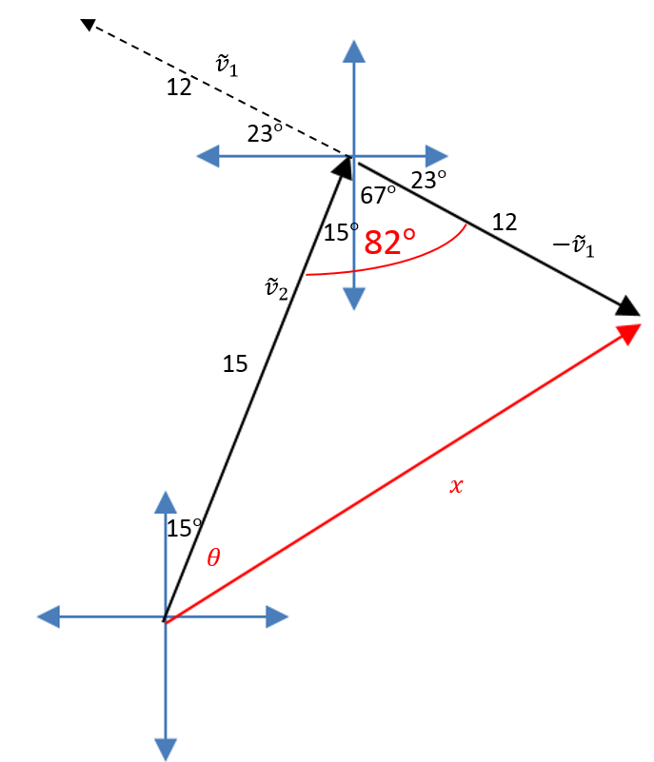
$$∴Bearing is 15+41.716…=56.716…°$$

$∴Change in velocity is 17.9m/s$ $on bearing of 56.7°.$
Alternate Working:
${\tilde{v}}_{1}=\left(\begin{matrix}12 \\ 157°\end{matrix}\right), {\tilde{v}}_{2}=\left(\begin{matrix}15 \\ 75°\end{matrix}\right)$

$∴{\tilde{v}}_{2}-{\tilde{v}}_{1}=\left(\begin{matrix}3.88… \\ 14.48…\end{matrix}\right)-\left(\begin{matrix}-11.046… \\ 4.67…\end{matrix}\right)=\left(\begin{matrix}14.928… \\ 9.800…\end{matrix}\right)$

$∴{\tilde{v}}_{2}-{\tilde{v}}_{1}=\left(\begin{matrix}17.9 \\ 33.3°\end{matrix}\right)$

$∴Change in velocity is 17.9m/s$ $on bearing of 56.7°$

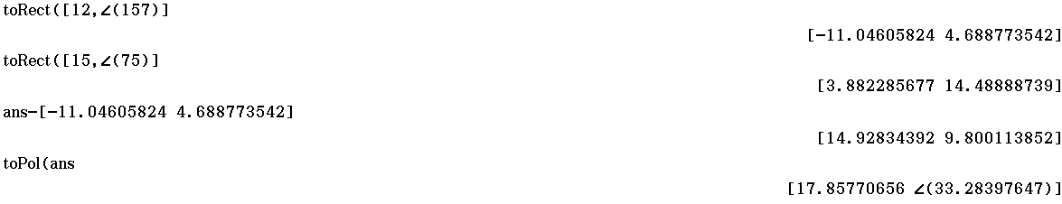

[6 marks]

